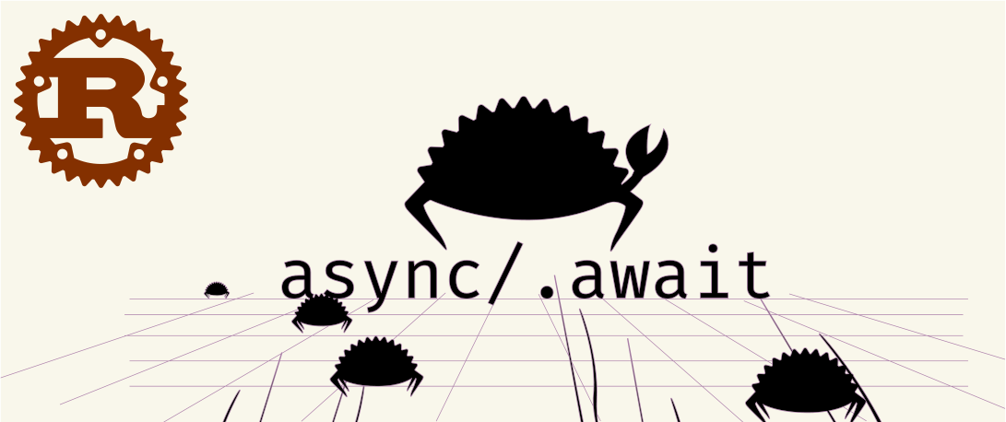

Async Definition:
In Rust, Async means to not wait for another task to be finish because it can run code concurrently or multiple task at the same time on a single thread. Multithreading is like this but has distinct concept. Mostly Multithreading is used when you’ve got computationally intensive task(so-called CPU-bound tasks). IO bound are the tasks which spends a lot of time waiting, such as for a response from the server.
Asynchronous Programming is the which let us run multiple of the IO bound computation at the same time on the single thread without wasting any time because when they are waiting for a response they’re just idle,so by the help of async we can let the computer keep working.

Why Async Rust:
A notable point about Rust is fearlessly concurrency. That is the notion that you should be empowered to do concurrent things without giving up safety. Also Rust being a low-level Language, it’s about fearlessly concurrency without picking a specific implementation strategy. This means we must abstract over the strategy, to allow choice later, if we want to share code between users of different strategy.

Futures:
Futures abstract over computation. They describe “what”, independent of “where” and the “when”. For that they aim to break cod e into small, composable actions that can be executed by a part of our system.

Let’s took an example to make it clearer:
use async_std::task;
// ^ we need this for task spawning
async fn negate_async(n: i32) -> i32 {
println!(“Negating {}”, n);
task::sleep(std::time::Duration::from_secs(5)).await;
println!(“Finished sleeping for {}!”, n);
n * -1
}
async fn f() -> i32 {
let neg = negate_async(1);
// … nothing happens yet
let neg_task = task::spawn(negate_async(2));
// ^ this task /is/ started
task::sleep(std::time::Duration::from_secs(1)).await;
// we sleep for effect.
neg.await + neg_task.await
// ^ this starts the first task `neg`
// and waits for both tasks to finish}
So in the above little code snippet here’s what’s going on.
· The first line imports async_std::task.
· The async function negate_async takes a input a signed integer, sleeps for 5 seconds and returns the negated version of that integer.
· The async function f is more interesting:
- The first line (let neg …) creates a Future of the negate_async function and assign it to the neg variable. Imortantly, it doesnot start executing yet.
- The next line of code (let neg_task …) uses the task::spawn function to start executing the Future returned by negate_async. Like with neg, the Future returned by negate_async is assigned to the neg_task variable.
- Next: we sleep for a second. This is so that it will be obvious from the output when a task starts running.
- Finally, we await both futures, add them together, and return them. By awaiting neg, we start executing the Future and run it to completion. Since neg_task has already been started, we just wait for it to finish.
So what’s the result of this , then?
Negating 2
# <- there’s a 1 second pause here
Negating 1
Finished sleeping for 2!
Finished sleeping for 1!
As we can see, the second future, neg_task, started executing as soon as it was called — thanks to task::spawn — while neg did not start executing until it was awaited.

